3/17/2026
LAB NO 06
COAL
Submitted to: Sir Imran
Submitted by: Wasif Ali (245187)
Task 01:
Result:
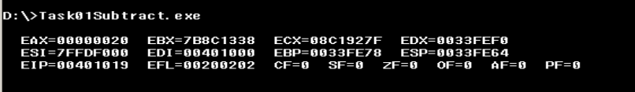
Result = 20

Code:
INCLUDE Irvine32.inc

.data

num1 WORD 50h
num2 WORD 20h
num3 WORD 10h

.code
main PROC

mov ax, num1
sub ax, num2
sub ax, num3

call DumpRegs ; show register values

exit
main ENDP

END main

Task 02:
Result:

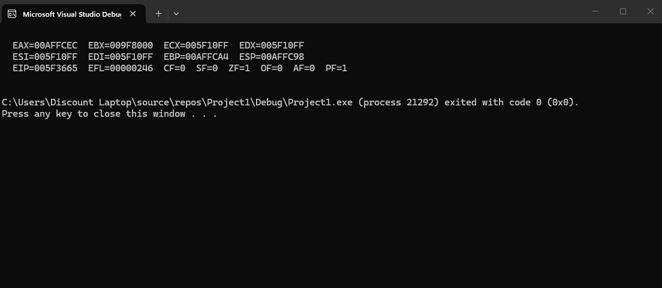

Code:
INCLUDE Irvine32.inc

.data

bVal BYTE 100
sbVal SBYTE -50
wVal WORD 30000
swVal SWORD -20000
dwVal DWORD 2000000000
sdwVal SDWORD -1000000000
fVal FWORD 123456789
qVal QWORD 1234567890123
tVal TBYTE 1234567890123456789
r4Val REAL4 3.14
r8Val REAL8 3.1415926535
r10Val REAL10 3.141592653589793

.code
main PROC

call DumpRegs ; show register values

exit
main ENDP

END main
Type | Usage
BYTE | 8-bit unsigned integer. B stands for byte
SBYTE | 8-bit signed integer. S stands for signed
WORD | 16-bit unsigned integer (can also be a Near pointer in real-address mode)
SWORD | 16-bit signed integer
DWORD | 32-bit unsigned integer (can also be a Near pointer in protected mode). D stands for double
SDWORD | 32-bit signed integer. SD stands for signed double
FWORD | 48-bit integer (Far pointer in protected mode)
QWORD | 64-bit integer. Q stands for quad
TBYTE | 80-bit (10-byte) integer. T stands for Ten-byte
REAL4 | 32-bit (4-byte) IEEE short real
REAL8 | 64-bit (8-byte) IEEE long real
REAL10 | 80-bit (10-byte) IEEE extended real

Task 03:

Result:

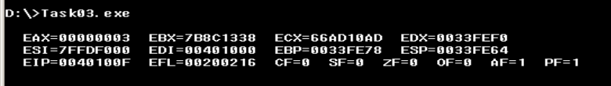

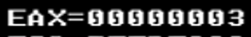

Result: Wednesday

Code:

INCLUDE Irvine32.inc

MONDAY EQU 1
TUESDAY EQU 2
WEDNESDAY EQU 3
THURSDAY EQU 4
FRIDAY EQU 5
SATURDAY EQU 6
SUNDAY EQU 7

.data

daysArray DWORD MONDAY, TUESDAY, WEDNESDAY, THURSDAY, FRIDAY, SATURDAY, SUNDAY

.code
main PROC

mov eax, daysArray
mov eax, daysArray+8 ;Wednesday
call DumpRegs ; show register values

exit
main ENDP

END main

Task 04:

Result:

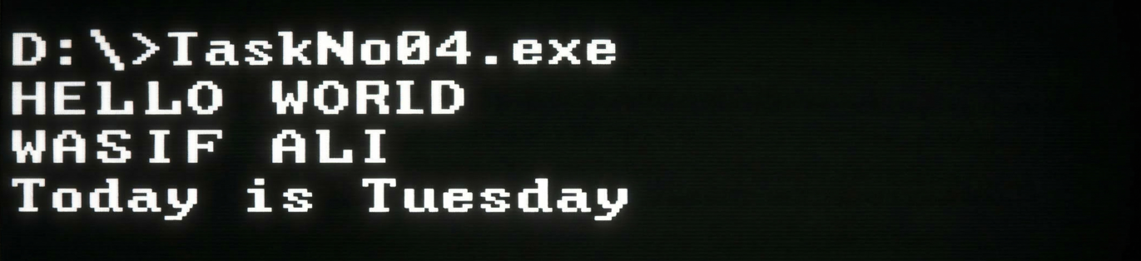

Code:

INCLUDE Irvine32.inc

HELLO_MSG EQU "HELLO WORLD"
NAME_MSG EQU "MOHSIN ALI"
DAY_MSG EQU "Today is Tuesday"

.data

msg1 BYTE HELLO_MSG,0
msg2 BYTE NAME_MSG,0
msg3 BYTE DAY_MSG,0

.code
main PROC

mov edx , offset msg1
call writeString
call Crlf

mov edx , offset msg2
call writeString
call Crlf

mov edx , offset msg3
call writeString
call Crlf

exit
main ENDP

END main

